# ASSESSMENT TO KEEP LEARNERS ACTIVE

**S.2 PHYSICS**

**TIME 2** 𝟏

𝟒

𝒉𝒐𝒖𝒓𝒔

## Name… Stream……

1. Your uncle operates one of the largest supermarkets in Hoima city however he has been having some challenges especially theft of his goods in his supermarket. What advice would you offer him using the knowledge of reflection of light to overcome such losses due to theft of his goods. (05 marks)

………………………………………………………………………………………………

………………………………………………….…………………………………………

………………………………………………………………………………………………

……….……………………………………………………………………………………

…………………………………………………………….………………………………

………………………………………………………………………………………………

………………………………………………………………………………………………

….…………………………………………………………………………………………

### The diagram shows the shape and dimensions of Teresa’s rose garden.

* 1. 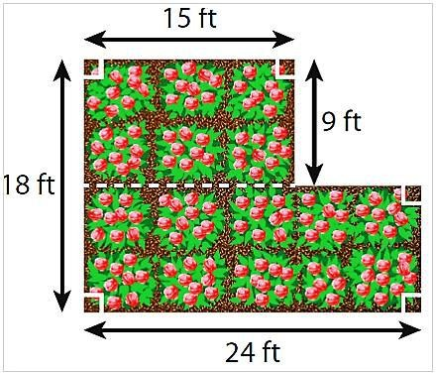Teresa wants to buy mulch for her garden. One bag of mulch covers 12 square feet. How many bags will she need? (05 marks)

…………………………………………………………………………………………………………

……………………………………….………………………………………………………………

………………………………………………………………………………….……………………

…………………………………………………………………………………………………………

………………….……………………………………………………………………………………

………………………………………………………………………………………………………………………………………………….…………

……………………………………………………………………………………………………………………………………….……………………

…………………………………………………………………………………………………………………………….………………………………

………………………………………………………………………………………………………………….…………………………………………

1. Potassium permanganate was put in the beaker having water as shown below.

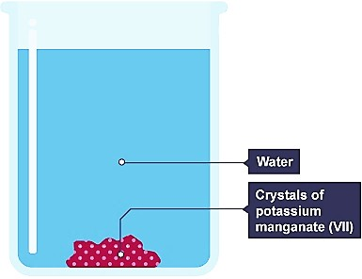a) Describe and explain what happens after some time. (05 mks)

………………………………………………………………

………………………………………………………………

………………………………………………………………

………………………………………………………………

………………………………………………………………………………………………

………………………………………………………………………………………………

………………………………………………………………………………………………

………………………………………………………………………………………………

1. Most truck drivers overload their trucks, and this has led to many road accidents which has claimed many innocent lives, loss of properties and has caused so much harm to our transportation sector in today’s economy. If you are appointed the traffic police officer in Uganda today, briefly explain **three** possible advice you can offer to truck drivers to minimise on the accidents caused by overloading of the truck. (05 marks)

………………………………………………………………………………………………

………………………………………………………………………………………………

………………………………………………………………………………………………

………………………………………………………………………………………………

………………………………………………………………………………………………

………………………………………………………………………………………………

………………………………………………………………………………………………

………………………………………………………………………………………………

……………………………………………………………………………………………

1. An object is pulled through a distance of **2 m** by a force of **55 N** on the first day. The same object is again pulled through a distance of **20 cm** by a force of **1500 N** on the second day. Calculate the work done on;

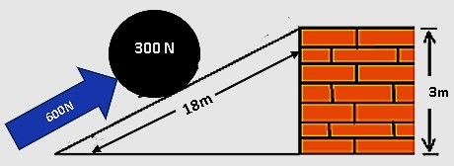

1. First day ( 02 mks)

………………………………………………………………………………………

………………………………………………………………………………………

………………………………………………………………………………………

1. Second day (02 mks)

………………………………………………………………………………………

………………………………………………………………………………………

………………………………………………………………………………………

1. On which day was much work done? And why do you think so? (01 mk)

……………………………………………………………………………………

1. A force of **600 N** is used to move a load of **3000 N** up an inclined plane. Given that the slanted height and vertical height of the plane are **18 m** and **3m** respectively.

Find

1. Velocity ratio of the plane (02 mks)
2. Mechanical advantage (02 mks)
3. Efficiency of the plane (01 mk)

………………………………………

………………………………………………………

……………………………………………………

……………………………………………………

……………….………………………

………………………………….……

…………………………………………………….………………………………………

……………………………………………………………………….……………………

………………………………………………………………………………………….…

………………………………………………………………………………………………

…………….………………………………………………………………………………

……………………………….……………………………………………………………

………………………………………………….…………………………………………

…………………………………………………………………….………………………

………………………………………………………………………………………………

………………………………………………………………………………………………

1. The figure below shows a metre rule balancing horizontally on a pivot
2. Locate the centre of gravity on the above metre rule using letter **G (01 mk)**
3. Briefly explain why the metre rule balances only at that point of contact. (03 mks)

…………………………………………………………………………………………

…………………………………………………………………………………………

…………………………………………………………………………………………

1. How useful is this knowledge of balancing the centre of gravity in real life (01 mk)

………………………………………………………………………………………….

1. 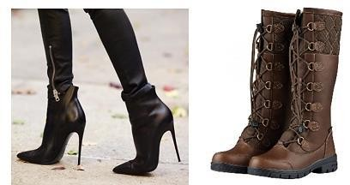If you're walking in snow, and you had these shoes to pick from for that exciting venture,
2. Which of the two shoes would you opt for? (01 mk)

**A B**

1. Briefly explain why you would wear that shoe in question 10 (a) above instead of the other? (03 mks)

…………………………………………………………………………………………

…………………………………………………………………………………………

…………………………………………………………………………………………

…………………………………………………………………………………………

1. What are the other applications of knowledge in other fields? (01 mk)

…………………………………………………………………………………………

## SECTION B (attempt only one question in this section) Question one

You have been hired by a discovery and jewel shop that deals with buying different

chemicals, jewels, minerals, and other rare earth metals. You have been provided with a table containing density of different substances in their pure form. You are required to help the company identify the pure substances to be purchased.

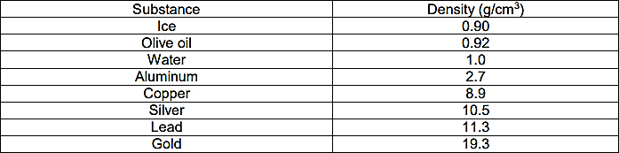

The second table below has all the substances that have been brought to the jewel shop to be purchased.

|  |  |  |
| --- | --- | --- |
| **Substance** | **Mass (g)** | **Volume (cm3)** |
| A shiny ring | 21 | 2 |
| A chunk of metal | 50 | 4.42 |
| A white solid | 63.72 | 23.6 |
| A brownish metal | 52.0 | 2.69 |

**TASK** (show all your working clearly)

As the newly hired shop attendant help the company identify each of the above substances so that you can pay the customers the rightful amount of money. (You can make use the first

table to help you identify the substances in the second table) (10 marks)

## Question two (10 marks)

A student wants to calculate the density of the two objects shown below: He however has some challenges in doing so help him write him all the procedures to be followed for accurate results. **SUPPORT MATERIAL**

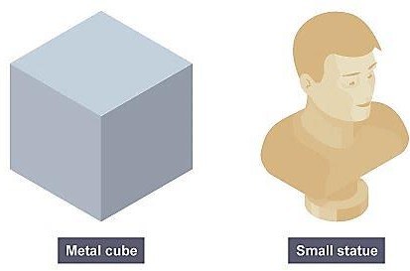

**Metal cube**

**statue**

# Question three (10 marks)

In the last decade oil and gas deposits were discovered in the Albertine region in western Uganda. During the world climate summit held in Egypt this year (2022), the European union were against Uganda’s plan to exploit the oil reserves. They believed that all new oil drilling should be stopped for the purposes of environmental preservation. They also claim the world should stop using fossil fuels and resort to cleaner energy sources which don’t harm the environment.

**Task**

Write a recommendation to the government of Uganda and the European union on the best possible ways of how this disagreement can be solved without harming the environment.

**The end**

**CONSULT MORE ON 0771940855 OR 0705476300**

**BY ONDERI KENNETH @2023 0771940855 / 0705476300** Page **9** of **9**